|  |
| --- |
| **PRODUCT DESIGN SPECIFICATION** |
| **JMC MUSIC PLAYER** |
| Programming III |

|  |
| --- |
| Jose Rico Imbang  12-11-2020 |

|  |  |  |  |  |  |
| --- | --- | --- | --- | --- | --- |
| **Version #** | **Implemented By** | **Revision Date** | **Approved By** | **Approval Date** | **Reason** |
| 1.0 | Jose Rico Imbang | 12/11/2020 | Dr Stewart Godwin |  |  |

# TABLE OF CONTENTS

1 INTRODUCTION 1

1.1 Purpose of the Product Design Specification Document 1

2 GENERAL OVERVIEW AND DESIGN GUIDELINES/APPROACH 2

2.1 Assumptions/Constraints/Standards 2

3 ARCHITECTURE DESIGN 3

3.1 Logical View 3

3.2 Hardware Architecture 3

3.3 Software Architecture 4

3.4 Security Architecture 4

3.5 Performance 4

4 SYSTEM DESIGN 5

4.1 Use-Case 5

4.2 Database Design 5

4.3 User Interface Design 6

5 PRODUCT DESIGN SPECIFICATION APPROVAL 7

## INTRODUCTION

### 1.1 Purpose of the Product Design Specification Document

The Product Design Specification document tracks the necessary information required to effectively define architecture and system design in order to give the development team guidance on architecture of the system to be developed. The Product Design Specification document is created during the Planning Phase of the project. Its intended audience is the project manager, project team, and development team. Some portions of this document such as the user interface (UI) may on occasion be shared with the client/user, and other stakeholder whose input/approval into the UI is needed.

## GENERAL OVERVIEW AND DESIGN GUIDELINES/APPROACH

### 2.1 Assumptions/Constraints/Standards

The application will not work in computers that is not running Windows operating system since it is developed especially for Windows computer. The computers that are going to be used must have .NET installed since the application will use its library. The user will not be able to use the application if the server application is not running. The songs that will be played are MP3 files and other audio formats will not be tested.

This application utilises [C# Coding Conventions](https://docs.microsoft.com/en-us/dotnet/csharp/programming-guide/inside-a-program/coding-conventions) to enhance its efficiency and for its maintainability.

## ARCHITECTURE DESIGN

### Logical View

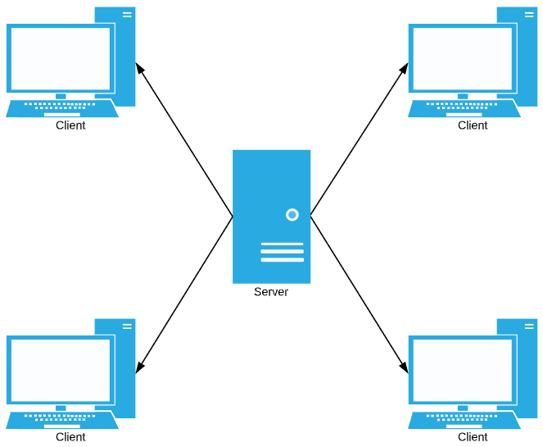

### 3.2 Hardware Architecture

The computers’ minimum hardware specification that are required to run the application are the following:

|  |  |
| --- | --- |
| Processor | 1 GHz |
| Memory | 2 GB |
| Storage | 32 GB |
| Graphics card | DirectX 9 or later with WDDM 1.0 driver |
| Display | 800x600 |

The clients must be in the same network with the server to be able to use the application.

### 3.3 Software Architecture

The program will work in computers running Windows operating system that at least has .NET, which is most likely already installed. It is necessary for the computer to have .NET installed since the program will use its library.

A CSV file contains the login information. The Server program has a User class. Running the Server program creates User objects that will contain the information from the CSV file and a 3rd party library will be used to read the CSV’s information. This program has a method for hashing passwords.

JMC Employees can use the application through a client. An employee logs in through the client and it verifies the login information to the server. The employee is able to use the music player if the login information is correct. The user can select the songs and the program will save the songs’ information into a binary tree and the GUI will show the track list. The user can play a song or search for a specific one (the program will utilise binary search algorithm). The user can also sort the music using merge sort algorithm.

### 3.4 Security Architecture

To be able to use the JMC Music Player application, the user needs to login with a username and a password through the client application. The username is in plain text while the password is hidden characters. The information is sent to the server application and the password is hashed. The username and the hashed password are then compared to the objects.

A default Admin login details is set.

### 3.5 Performance

A CSV file contains all the songs’ information and a 3rd party library will be used to read this information from the CSV file. Opening the application will store the songs into a binary tree and the GUI will show the track list. The user can search a song and it will be highlighted if found. The program will utilise binary search algorithm to search for a song. The songs can also be sorted using merge sort algorithm.

## SYSTEM DESIGN

### Use-Case

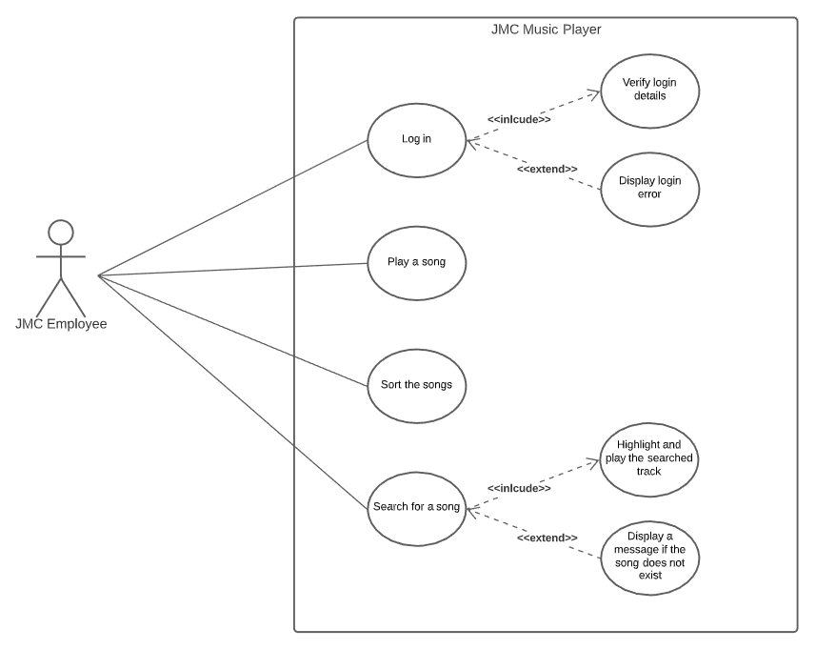

### Database Design

A CSV file will contain the login information and it includes the username and the hashed password.

### User Interface Design

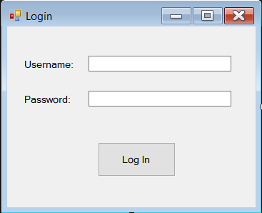

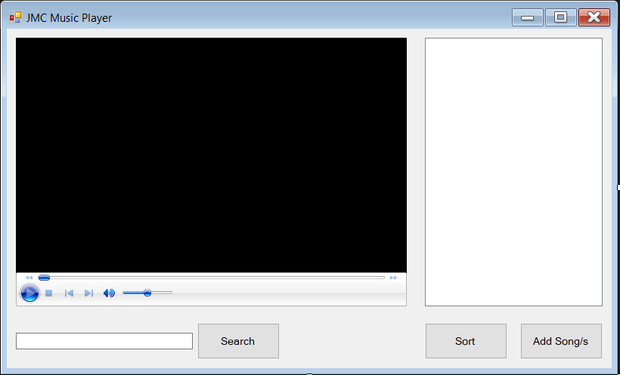

## 5 PRODUCT DESIGN SPECIFICATION APPROVAL

The undersigned acknowledge they have reviewed the **JMC Music Player** **Product Design Specification** document and agree with the approach it presents. Any changes to this Requirements Definition will be coordinated with and approved by the undersigned or their designated representatives.

|  |  |  |  |
| --- | --- | --- | --- |
| Signature: |  | Date: |  |
| Print Name: |  |  |  |
| Title: |  |  |  |
| Role: |  |  |  |